Flash ADC
Name: Sualeh Abbas & Burair Haider | Student ID: 10303, 09628
5.1 Objective
- To understand the working principle of a flash (direct-conversion) analog-to-digital converter.
- To design and simulate a 3-bit flash ADC in Simulink and study quantization error and resolution.
- To implement a 2-bit flash ADC in hardware using comparators, a resistor reference ladder, and logic gates.
- To compare simulated and real hardware behavior, and identify practical limitations of the flash ADC architecture.
5.2 Troubleshooting Guidelines
- Make sure the pins of the LM358 are accurately identified and connected: Pin 1 = Output A, Pin 2 = Inverting input A, Pin 3 = Non-inverting input A, Pin 4 = GND, Pin 5 = Non-inverting input B, Pin 6 = Inverting input B, Pin 7 = Output B, Pin 8 = V+.
- Make sure every logic gate IC (7486, 7404, 7408) has its Vcc and GND pins connected, separately from its signal input/output pins.
- Make sure the polarity of every LED is correct: the longer leg (anode) goes toward the gate output/resistor, and the shorter leg (cathode) goes toward GND.
- Confirm the reference ladder resistors and the potentiometer are connected to the same supply rail and common ground as the rest of the circuit.
- Use a multimeter to verify supply voltages at every IC before assuming a fault is a logic error.
- If an output appears stuck or incorrect, probe the signal stage by stage (comparator output, gate input, gate output, LED) to isolate exactly where the fault occurs.
- Check for floating/unconnected inputs on any comparator or gate, as these can cause unpredictable output behavior.
5.3 Introduction
An Analog-to-Digital Converter (ADC) converts a continuous analog voltage into a discrete digital representation. Among the various ADC architectures, the flash ADC (also called a direct-conversion ADC) is the fastest, since it performs the entire conversion in a single step using a bank of parallel comparators rather than any iterative or successive process.
In this experiment, a 3-bit flash ADC is designed and simulated in Simulink, and a 2-bit flash ADC is implemented on hardware using op-amp comparators, a resistor reference ladder, and discrete logic gates for encoding. The exercise is intended to build an understanding of ADC resolution, quantization error, and the practical differences between simulated and real circuit behavior.
5.4 Theory
5.4.1 Flash ADC Architecture
A flash ADC converts the analog input to digital in a single clock step using a bank of parallel comparators, making it the fastest ADC topology available. It consists of three main stages:
- Reference ladder: a chain of equal-value resistors connected between a reference voltage (Vref) and ground, creating evenly spaced threshold voltages. For an n-bit flash ADC, 2ⁿ resistors are required, producing 2ⁿ − 1 usable reference taps.
- Comparator bank: 2ⁿ − 1 comparators, each comparing the analog input (Vin) against one reference tap. As Vin rises, comparators trip in order from the lowest to the highest threshold, producing a thermometer code (an unbroken run of 1s from the bottom up, similar to mercury rising in a thermometer).
- Encoder: converts the thermometer code into standard n-bit binary output, using either a dedicated priority encoder IC or discrete logic gates.
Because all comparisons happen simultaneously, flash ADC conversion time is limited only by comparator switching speed and encoder gate delay, making it the fastest ADC architecture. However, the number of comparators grows as 2ⁿ − 1, so component count, power consumption, and chip area scale exponentially with resolution. This is the central design tradeoff of the flash ADC: very high speed, at the cost of poor scalability to higher bit resolutions.
Task 1: 3-Bit Flash ADC (Simulink Simulation)
Design a 3-bit flash ADC in Simulink using 7 comparator blocks referenced to seven evenly spaced DC reference voltages (Vref/8 through 7Vref/8, generated from an 8-resistor reference ladder), with a lookup table or logic block implementing the thermometer-to-binary encoder. Apply a ramping (sawtooth) input signal and observe the digital output response.
Take V_{ref} = 8 V. Apply a sawtooth input signal with an amplitude of 8 V (from 0 V to 8 V) and a frequency of 1 Hz.
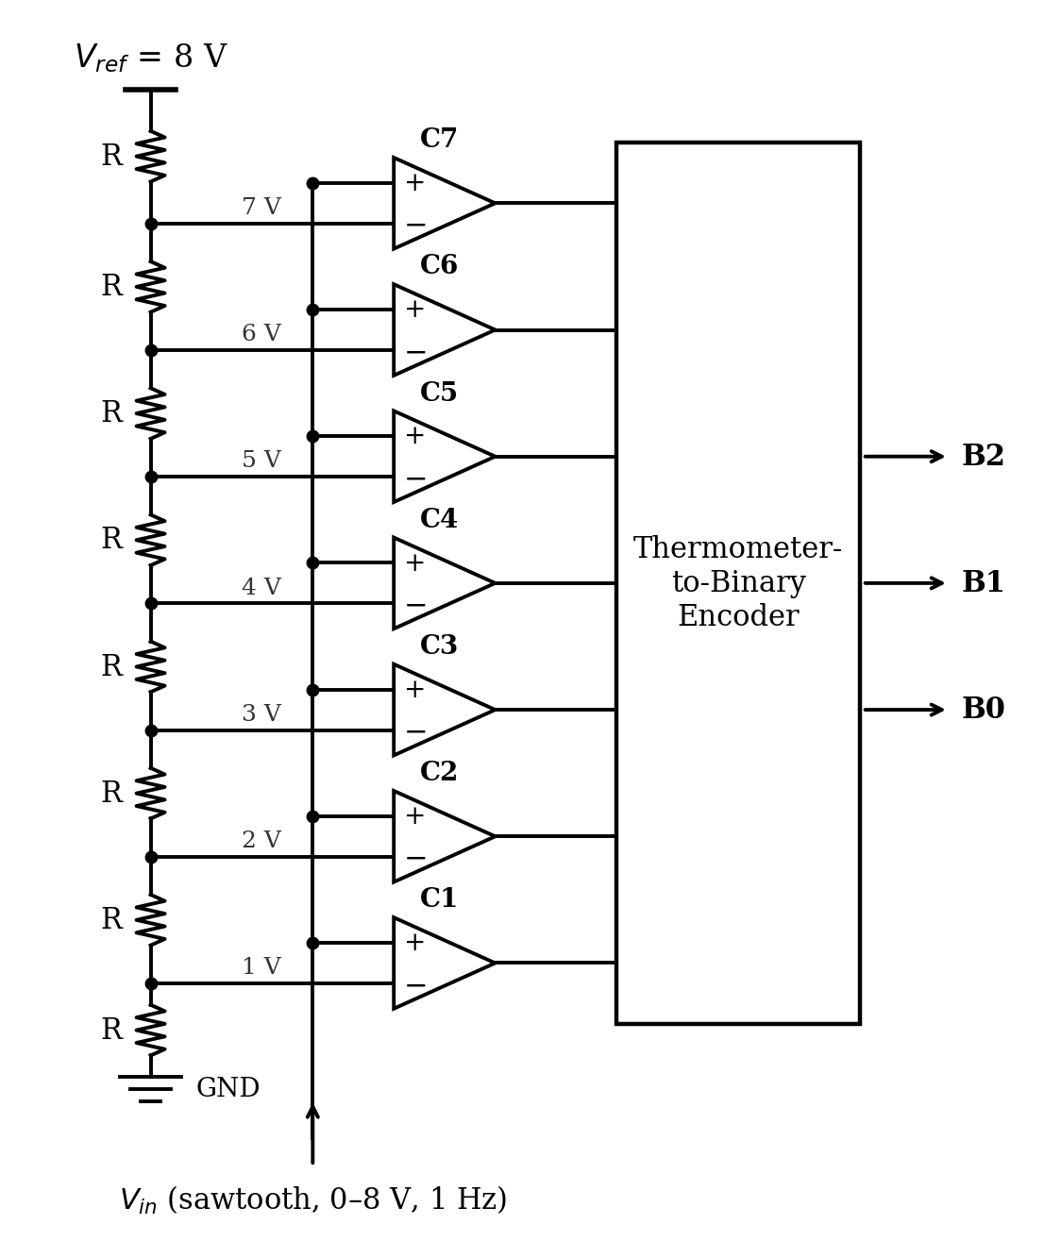
Figure 1: 3-bit Flash ADC
Output
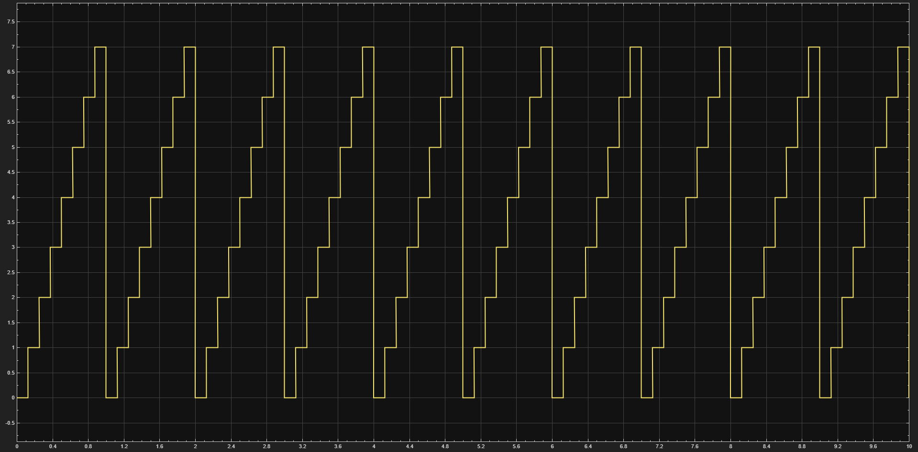

Vin (approx.) | C1 | C2 | C3 | C4 | C5 | C6 | C7 | B2 | B1 | B0
0 V – 1 V | 0 | 0 | 0 | 0 | 0 | 0 | 0 | 0 | 0 | 0
1 V – 2 V | 1 | 0 | 0 | 0 | 0 | 0 | 0 | 0 | 0 | 1
2 V – 3 V | 1 | 1 | 0 | 0 | 0 | 0 | 0 | 0 | 1 | 0
3 V – 4 V | 1 | 1 | 1 | 0 | 0 | 0 | 0 | 0 | 1 | 1
4 V – 5 V | 1 | 1 | 1 | 1 | 0 | 0 | 0 | 1 | 0 | 0
5 V – 6 V | 1 | 1 | 1 | 1 | 1 | 0 | 0 | 1 | 0 | 1
6 V – 7 V | 1 | 1 | 1 | 1 | 1 | 1 | 0 | 1 | 1 | 0
7 V – 8 V | 1 | 1 | 1 | 1 | 1 | 1 | 1 | 1 | 1 | 1
- What is quantization error?
Quantization error is the difference between the actual continuous analog input value and the discrete digital step val. Because the ADC rounds a range of analog voltages into a single digital code, information is ofcourse lost.
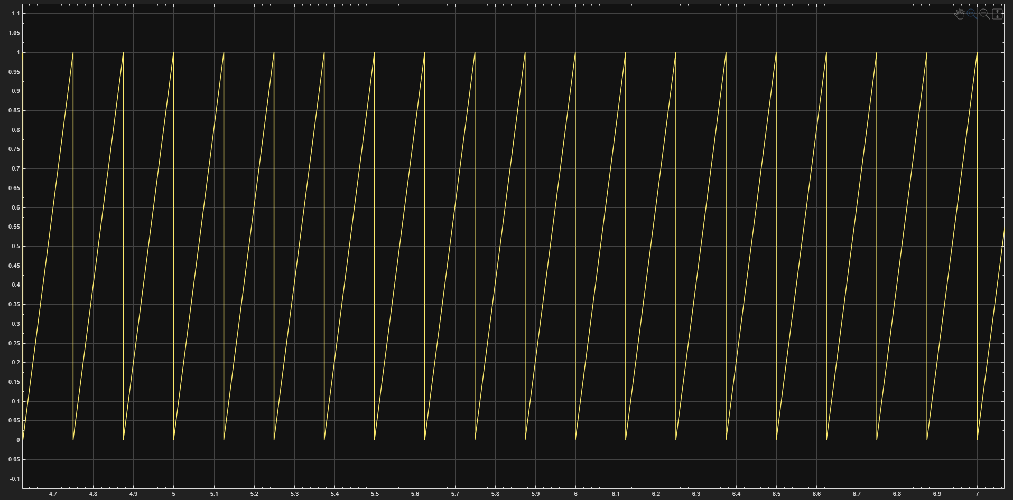
- Plot a sawtooth wave diagram
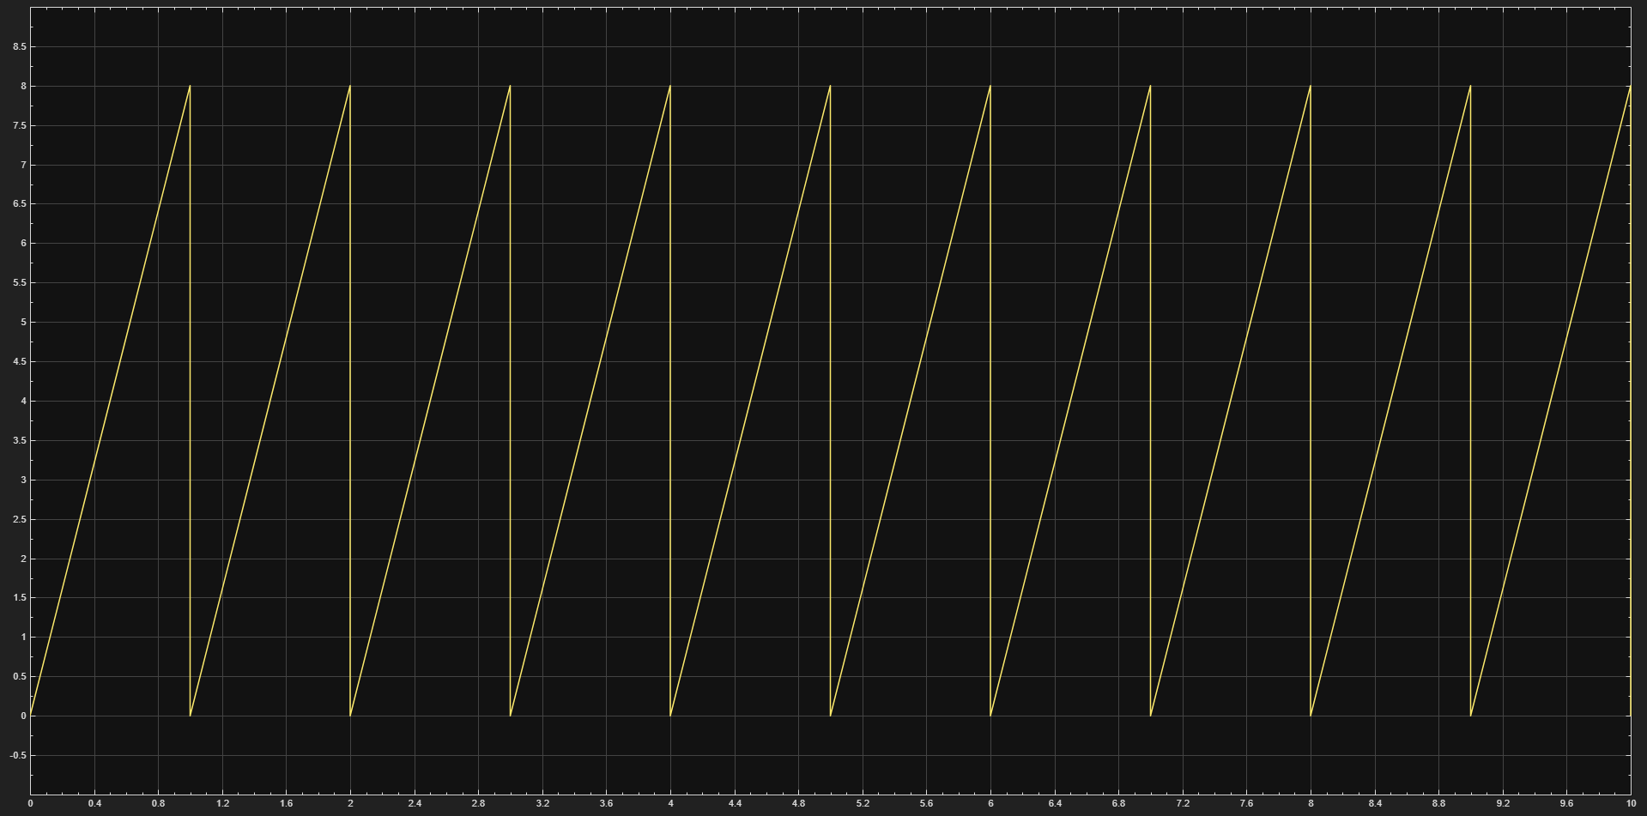
- Why is it exactly equal to 1 LSB (one step)?
In this specific design, the reference ladder utilizes 8 equal-value resistors connected to an 8 V reference. This divides the reference into exactly 1 V steps (the resolution). Because the flash ADC transitions its digital output only when the analog input crosses these specific 1 V thresholds, the maximum voltage difference between the analog input and the lower digital threshold code before it trips the next comparator is exactly 1 V, which equates to 1 Least Significant Bit (LSB).
- How can we optimize the circuit or reduce the propagation delay? Is the real hardware output expected to differ from the Simulink simulation?
To reduce propagation delay in the encoder stage, dedicated priority encoder ICs can be utilized instead of chaining multiple discrete logic gates. Simulation assumes ideal components with zero switching time. Real hardware behavior will differ due to several practical limitations:
- Gate Delays: Physical logic gates and op-amps introduce inherent switching and propagation delays.
- Component Tolerances: Slight variations in the reference ladder resistors will cause the threshold voltages to deviate from perfectly even 1 V steps, introducing non-linearity.
- Noise & Offsets: Physical comparators have input offset voltages and are susceptible to breadboard noise, which can cause flickering or incorrect bit switching near the threshold boundaries.

Task 2: 2-Bit Flash ADC (Hardware Implementation)
Implement a 2-bit flash ADC on a breadboard using the circuit shown in Figure 2. The reference ladder (R1–R4, 1kΩ each) is connected across a +5V supply, creating threshold taps at 1.25V, 2.5V, and 3.75V. A 50kΩ potentiometer (RP1) supplies the sweepable analog input (Vin) to all three comparators. Attach images of the breadboard, ensure that the LEDs are visible. Fill the table
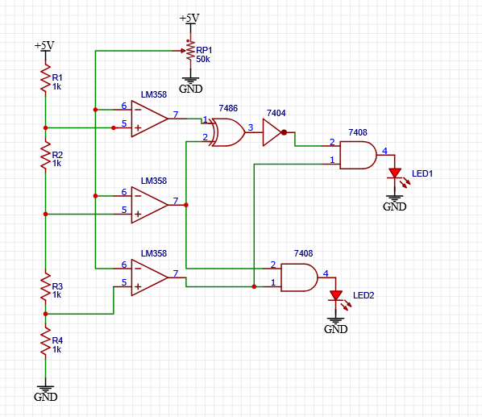
Figure 2: 2-bit Flash ADC
00 | 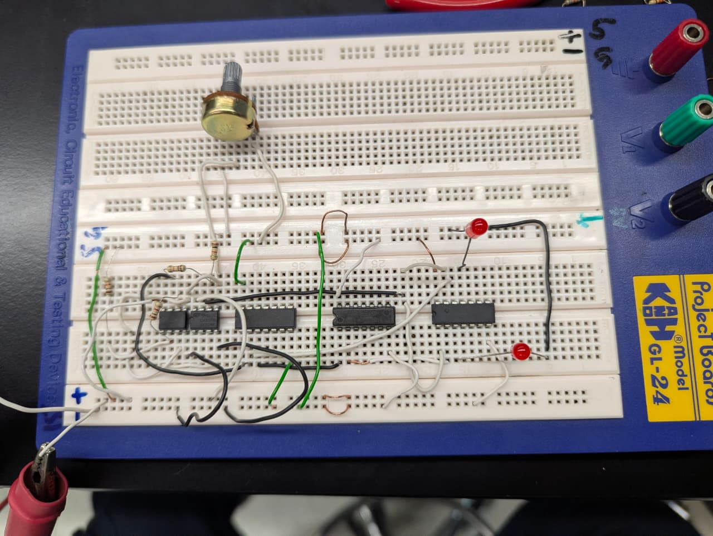
01 | 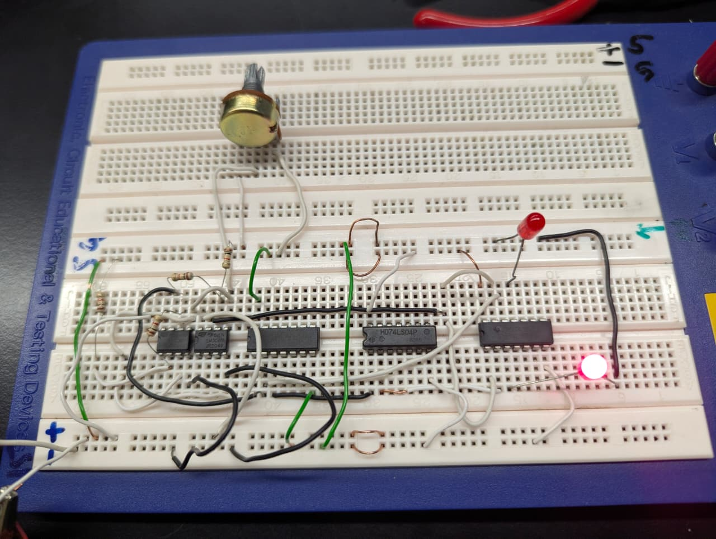
10 | 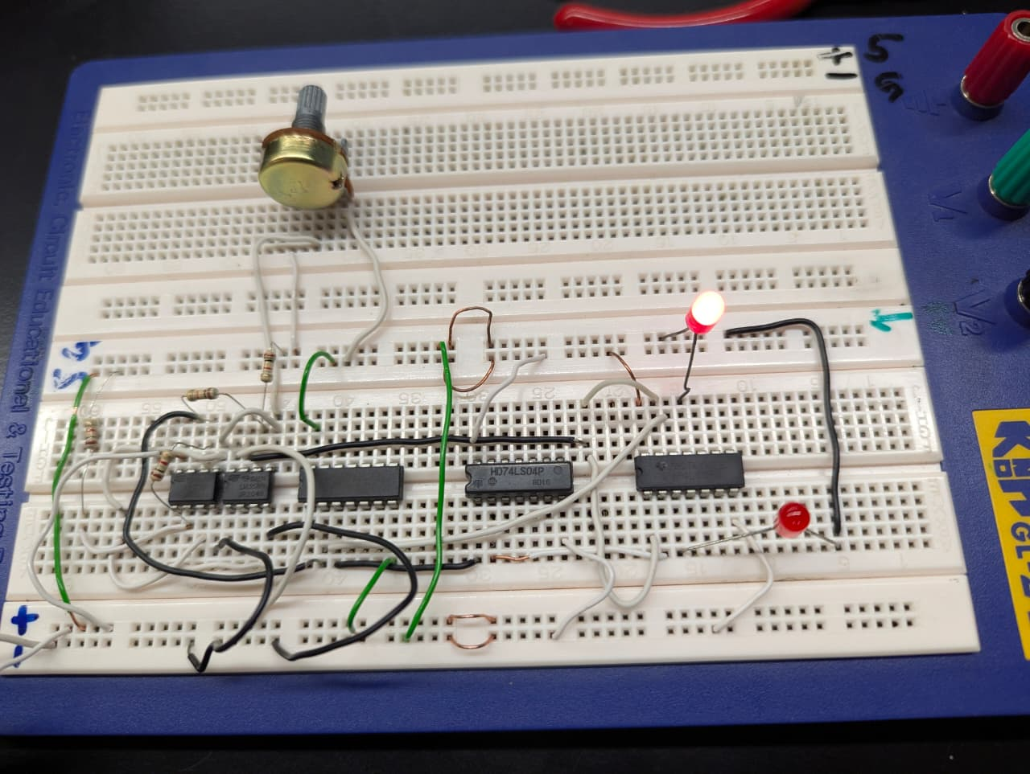
11 | 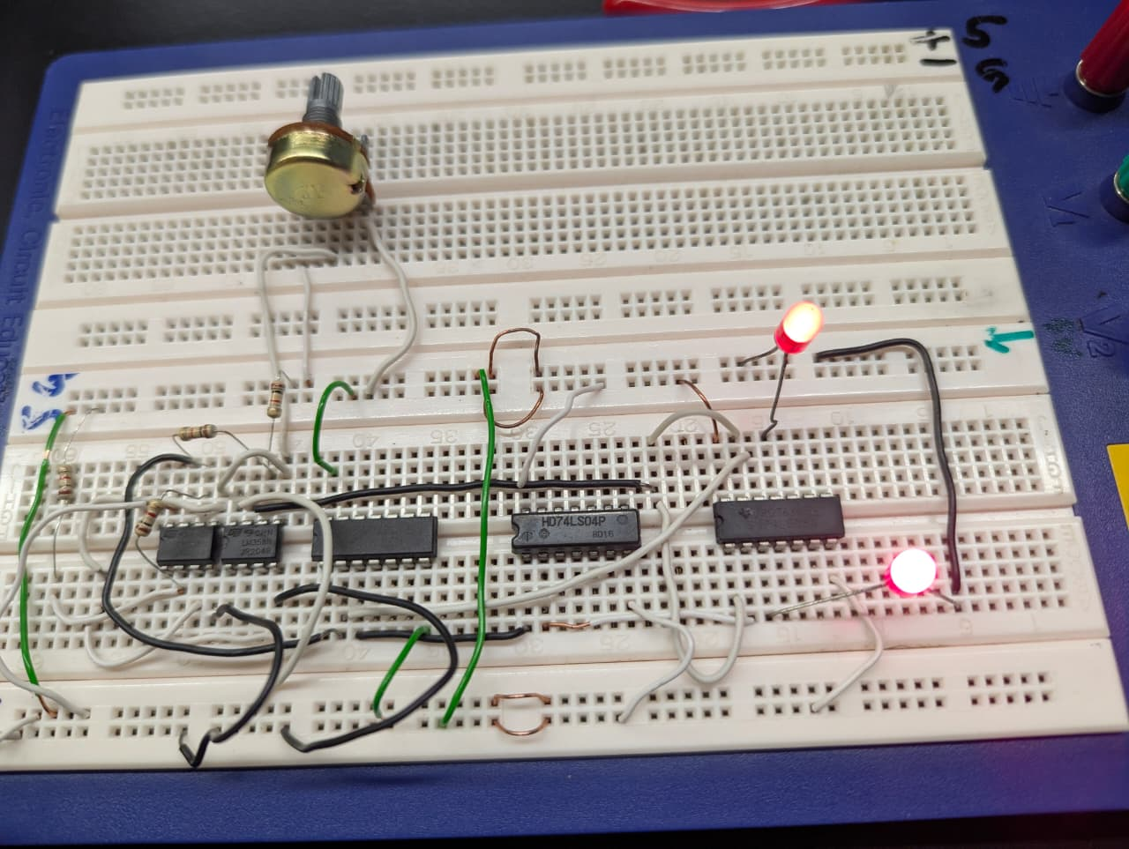

Vin (approx.) | C1 | C2 | C3 | B1 | B0
0 V – 1.25 V | 0 | 0 | 0 | 0 | 0
1.25 V – 2.5 V | 1 | 0 | 0 | 0 | 1
2.5 V – 3.75 | 1 | 1 | 0 | 1 | 0
3.75 V – 5 V | 1 | 1 | 1 | 1 | 1
- Why did we not use the LM741 IC?
• Single-Supply Operation: The LM358 is designed for single-supply operation (0 V to 5 V) and its input common-mode range includes Ground (0 V). The LM741 requires dual balanced power supplies (+-15v) to operate correctly near 0 V; on a single +5v supply, its input/output saturation voltages would prevent proper switching near ground.
• Package Density: The LM358 contains two independent operational amplifiers in an 8-pin dual in-line package. The LM741 contains only one op-amp per 8-pin package, requiring twice as many ICs on the breadboard.
• Speed/Slew Rate Limitations: Standard general-purpose op-amps like the LM741 have poor slew rates and large phase delays compared to dedicated low-voltage op-amps/comparators like the LM358, leading to slow output state transitions.
- What are the limitations of implementing a 3-bit ADC on a breadboard? Explain.
• Exponential Component Count (2^n - 1): A 3-bit flash ADC requires 7 comparators (2^3 - 1) and an 8-resistor reference ladder. Implementing this requires 4 physical LM358 ICs (or two LM339 quad-comparators), leading to excessive breadboard wiring, higher component density, and increased risk of loose connections or cross-talk.
• Increased Priority Encoder Logic Complexity: A 2-bit ADC only requires 3 comparators and a few logic gates. A 3-bit ADC requires converting a 7-bit thermometer code into a 3-bit binary output (B_2, B_1, B_0), which requires significantly more logic gates (AND, OR, NOT, XOR gates) or a dedicated 8-to-3 priority encoder IC (e.g., 74LS148). Chaining discrete gates adds notable propagation delay.
• Resistor Tolerance and Loading Effects: Small tolerance errors in individual resistors across an 8-resistor chain accumulate, causing uneven threshold tap voltages and non-linear step sizes. Additionally, input bias currents from 7 parallel comparator inputs pull current from the reference nodes, degrading accuracy unless buffered.
• Breadboard Capacitance & Noise: High wiring density on a solderless breadboard introduces stray capacitance and noise, causing input oscillations or output bit flickering around the threshold boundary voltages

Name & ID:_______________________________ Date: ______________
EE-322L Analog and Digital Communications Lab  Fall 2026  Habib University  Dhanani School of Science & Engineering | 
Lab#05 Flash ADC
Lab #5 Marks distribution:
 |  | LR1=30 | LR3=20 | LR5=20 | LR6=10 | AR4=20
In-Lab Tasks | Task 1 | /15 | /10 | / 10 | / 10 | / 20
In-Lab Tasks | Task 2 | /15 | /10 | / 10 | / 10 | / 20
Total Marks | /100

CLO 2 - (Psych-4)

Lab Evaluation Assessment Rubric
# | Assessment Elements | (0<Level 1<=4) | (4< Level 2<=6) | (6< Level 3<=8) | (8< Level 4<=10)
LR1 | Neat and Clean Circuit layout | Components are wired and didn't show neat and clean connections and minimal efforts shown. | Components are wired with untidy connection and didn't show neat and clean connections | Few but not all Components are wired with neat and clean connections | Complete components are wired with neat and clean tight connections. Given task completed in due time.
LR3 | Troubleshooting | Unable to identify the fault/minimal effort shown | Able to identify the fault but unable to remove it. | Able to identify the fault but partially removes it. | Able to identify the fault and able to make necessary steps and actions to correct it.
LR4 | Data Collection | Measurements are incomplete, inaccurate and imprecise. Observations are incomplete or not included. Symbols, units and significant figures are not included | Measurements are somewhat inaccurate and very imprecise. Observations are incomplete or recorded in a confusing way. Major errors using symbols, units and significant digits | Measurements are mostly accurate. Observations are generally complete. Minor errors using symbols, units and significant digits | Measurements are both accurate and precise. Observations are very thorough. Includes appropriate symbols, units and significant digits and completed in due time.
LR5 | Results & Plots | Figures, graphs, tables contain errors or are poorly constructed, have missing titles, captions, units missing or incorrect, etc. | Most figures, graphs, tables OK, some still missing some important or required features | All figures, graphs, tables are correctly drawn, but some have minor problems or could still be improved | All figures, graphs, tables are correctly drawn and contain titles/captions.
LR6 | Clean-up | All equipment/PC is not powered off. All items left at station and not cleaned. | Many equipment/PC is not powered off. Many items left at station. | Some equipment/PC is not powered off. Some items left at station. | All equipment/PC is powered off. Station left neat and clean.
LR8 | Contribution | No participation towards the group tasks | Slight participation towards the group tasks | Substantial participation towards the group tasks | Outstanding participation towards the group tasks
LR9 | Report | No summary provided. The number/ amount of tasks completed below the level of satisfaction and/or submitted late. | Couldn't provide good summary of in-lab tasks. Some major tasks were completed but not explained well. Submission on time. Some major plots and figures provided. | Good summary of In-lab tasks. All major tasks completed except few minor ones. The work is supported by some decent explanations, Submission on time, All necessary plots, and figures. provided | Outstanding Summary of In-Lab tasks, All task completed and explained well, submitted on time, good presentation of plots and figure with proper label, titles and captions.
AR4 | *Report Submission | Late submission after 1 week. | Late submission after 4 days and within a week. | Late submission after the lab timing and after 2 days of the due date. | Timely submission of the report and in lab time.
*Report: Report will not be accepted after 1 week of due date

